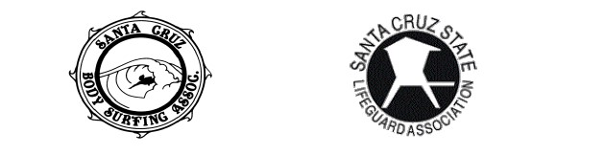
37th ANNUAL CALIFORNIA
BODYSURFING CHAMPIONSHIPS
7:30 a.m., Saturday, Oct. 23, 2021

Laguna Creek Beach, Santa Cruz County
$50 per entry (limited beach entries at $75)

More Info: SANTACRUZBODYSURFING.ORG

Name: _____________________________________________________________ Phone: ________________________ Age: _____ T-shirt Size: S / M / L / XL
Email: ____________________________ Cell Phone: ______________________
Address: ___________________________________________________________

DIVISIONS (Ages 16+)* □ Men □ Women

- _____Yes! Sign me up! Here’s my $50. (Via PayPal or Check)
- Yes! I’ll be at the post-contest BBQ and I’ll bring _____ guests.
- We can bring ________________________________ to share.

PAYPAL: bodysurfsantacruz@gmail.com

MAKE CHECKS PAYABLE TO: Santa Cruz State Lifeguard Association
MAIL CHECKS TO: SCSLA c/o Pat Malo, 239 Suburbia Ave, Santa Cruz, California 95062

